

|  |  |
| --- | --- |
|  | Lab 9 |
|  |  |
|  | Akshar panchani- ID 202101522  CT303 Digital Communication  11/19/23 |

**Experiment 1:**

Data Bit: 32-bit

Data Rate: 2KHz   
CH1: TP1 CH1: TP1

CH2: TP2 CH2:TP2

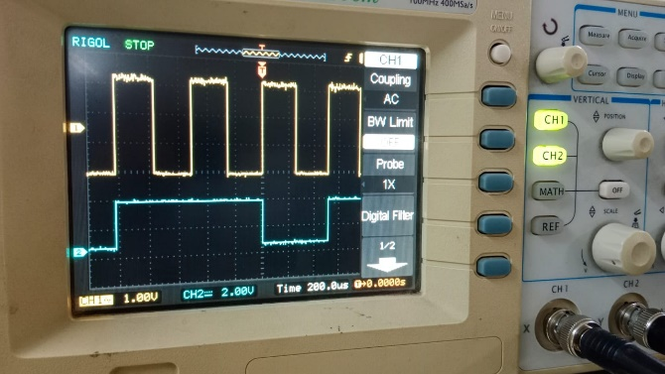 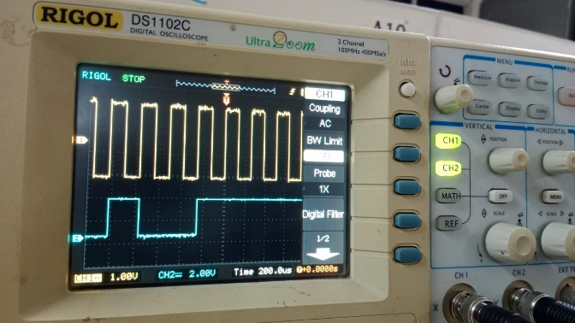

CH1: TP1 CH2: TP2

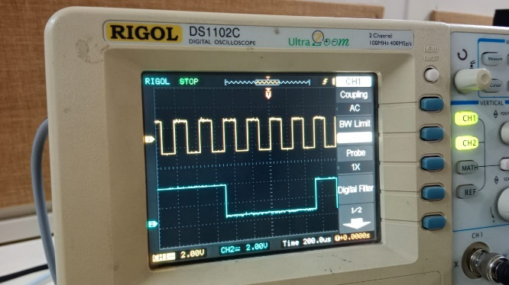

CH1: TP1 CH2: TP2 CH3:TP3 CH4:TP4

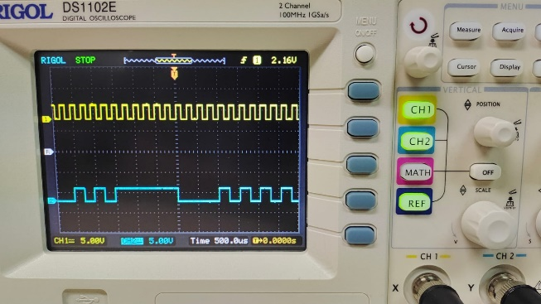 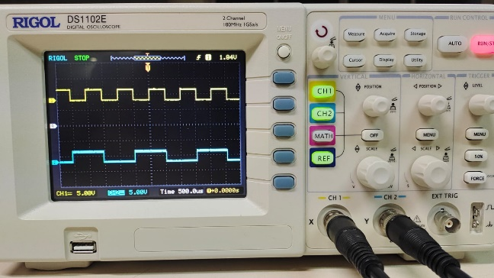

CH1: TP1 CH2: TP2 CH3:TP3 CH4:TP4

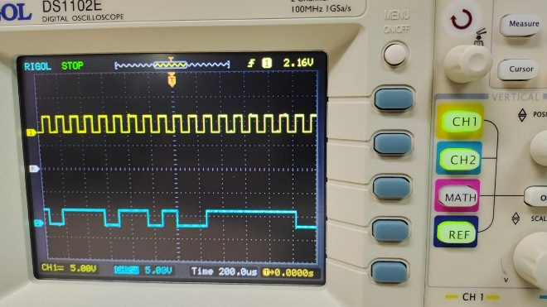 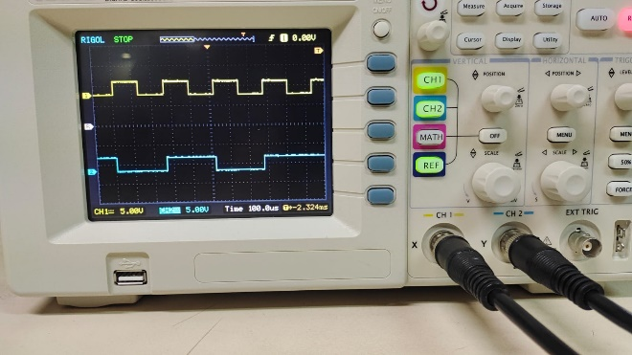

CH1: TP1 CH2: TP2 CH3:TP3 CH4:TP4

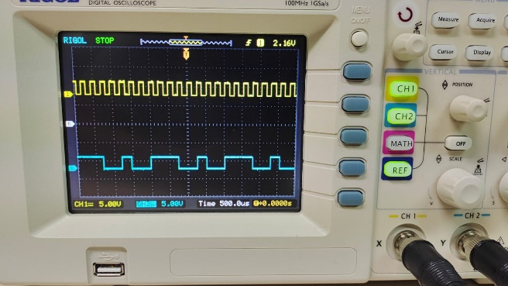 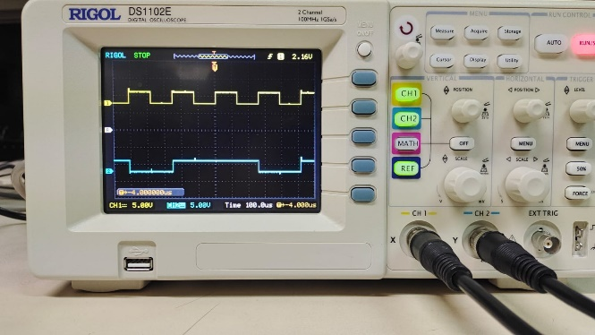

CH1: TP5 CH2: TP6

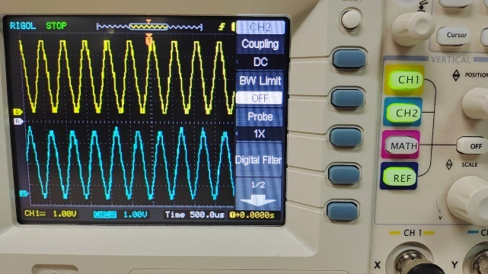

CH1: TP3 CH1: TP4

CH2: TP7 CH2:TP8

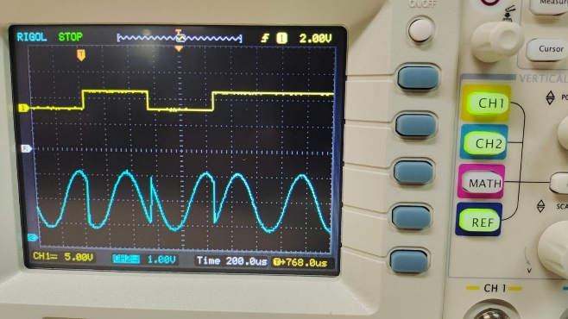 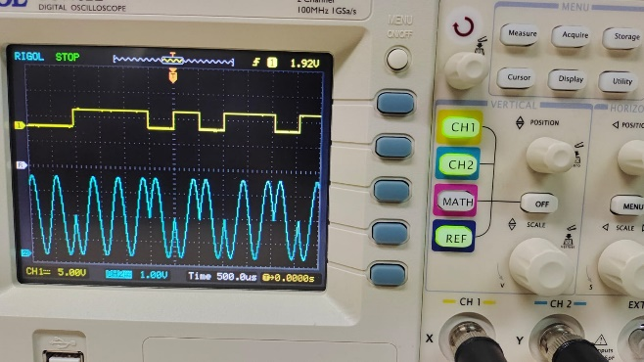

CH1: TP3 CH2: TP4 CH3:TP9

 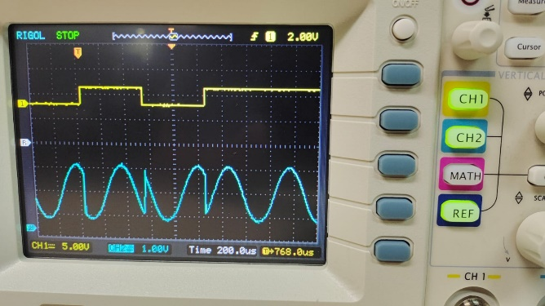

CH1: TP3 CH2: TP4 CH3:TP9

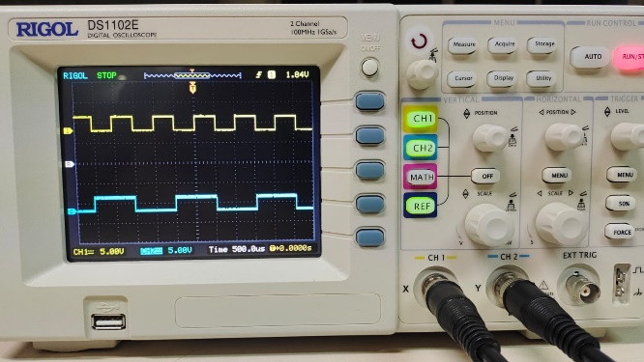 

CH1: TP3 CH2: TP4 CH3:TP9

 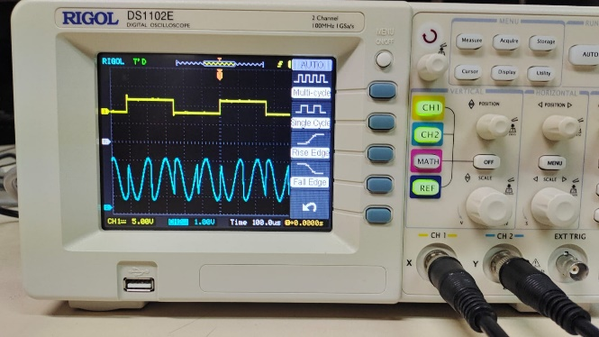

CH1: TP9 CH1: TP9

CH2: TP10 CH2:TP11

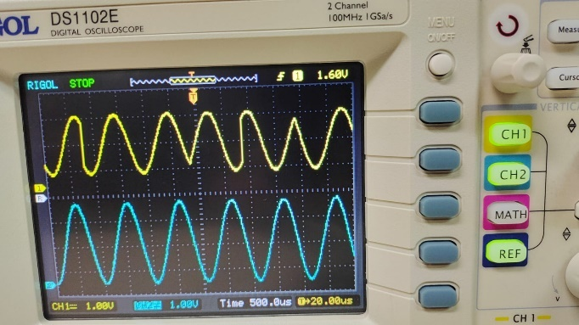 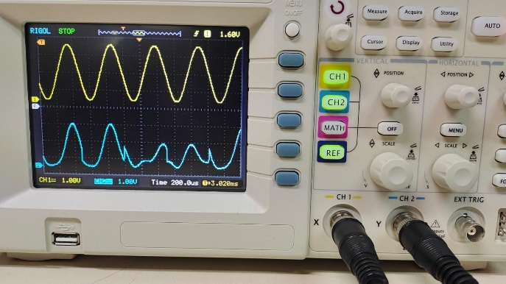

CH1: TP9 CH1: TP9

CH2: TP12 CH2:TP12

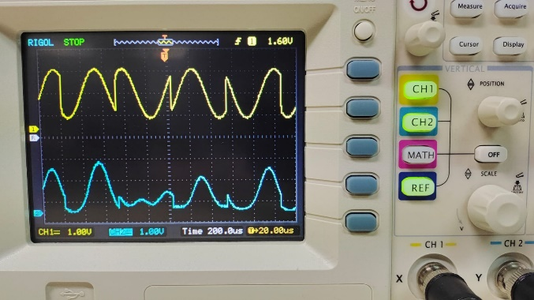 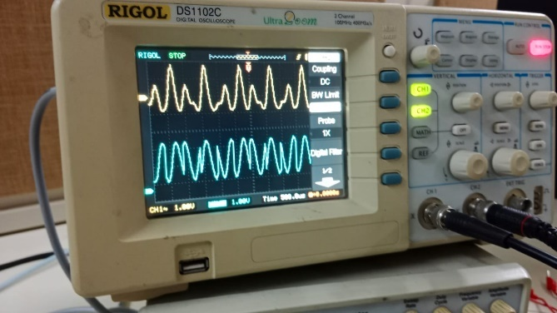

CH1: TP10 CH1: TP10

CH2: TP12 CH2:TP12

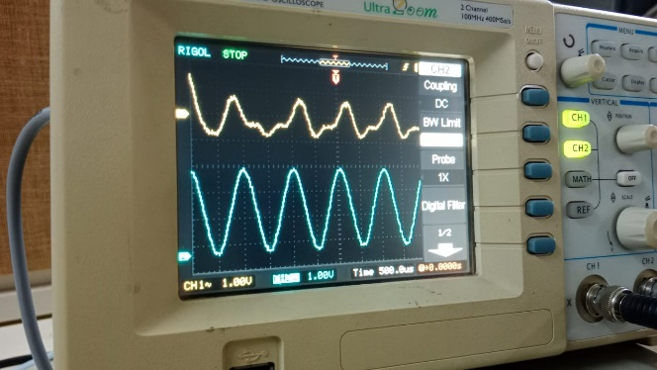 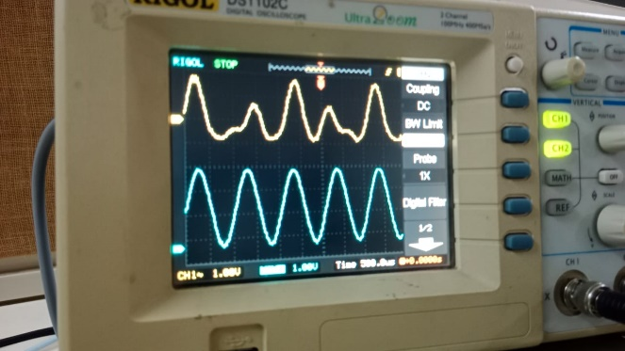

CH1: TP9 CH1: TP9

CH2: TP13 CH2:TP18

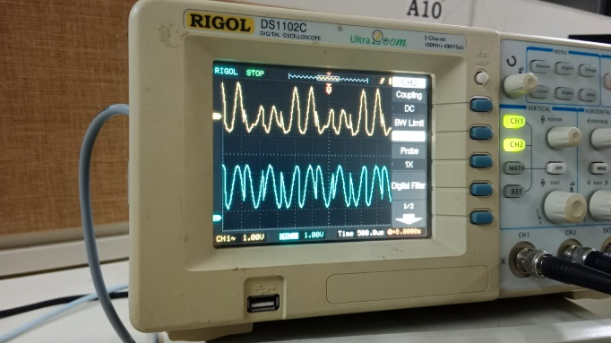 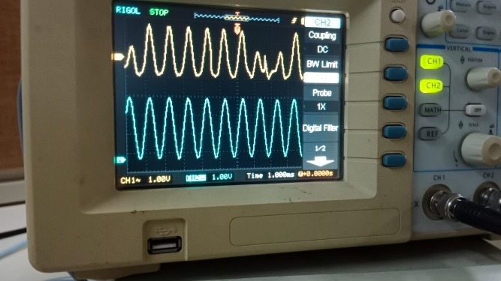

CH1: TP11 CH1: TP11

CH2: TP13 CH2:TP13

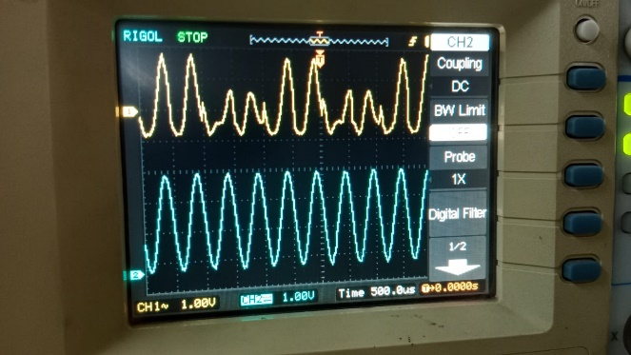 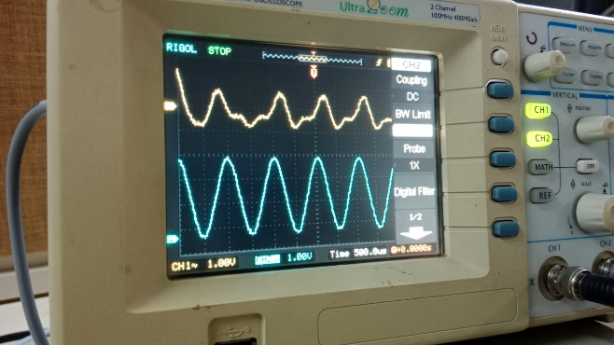

CH1: TP12 CH1: TP12

CH2: TP14 CH2:TP14

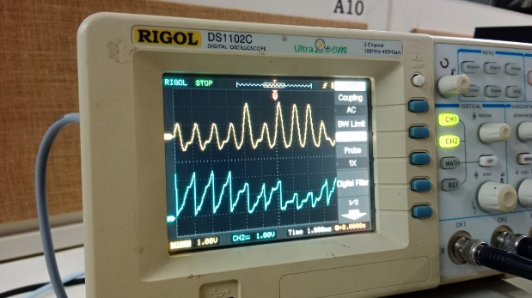 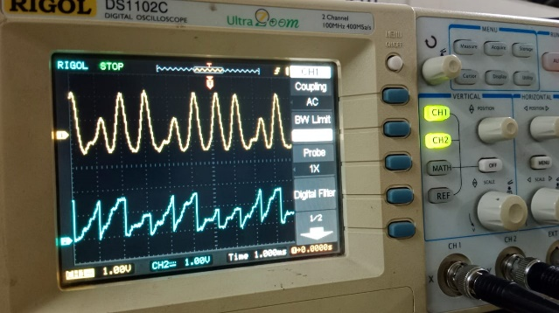

CH1: TP13 CH1: TP13

CH2: TP15 CH2:TP15

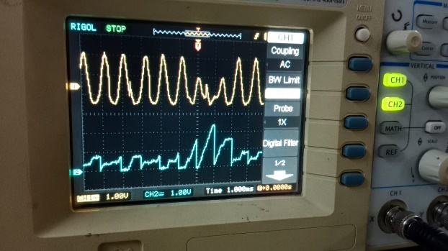 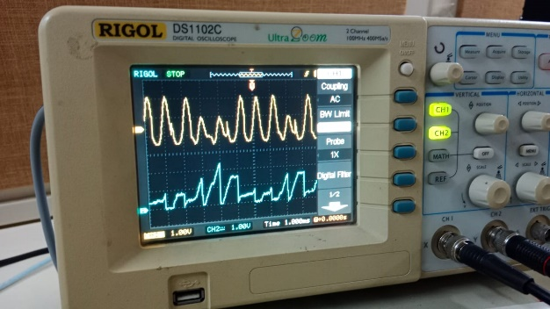

CH1: TP14 CH1: TP14

CH2: TP16 CH2:TP16

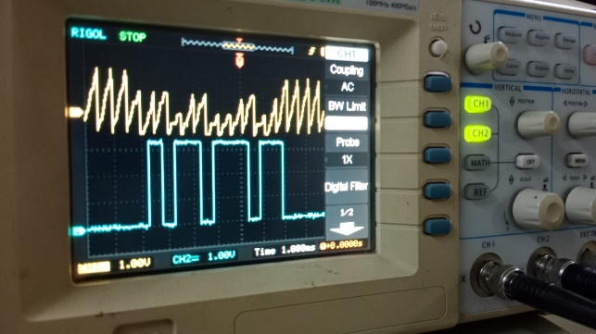 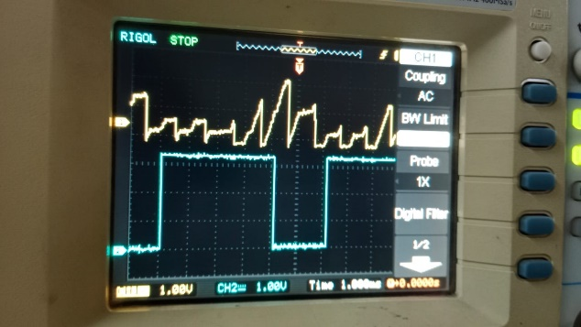

CH1: TP14 CH1: TP15

CH2: TP16 CH2:TP17

 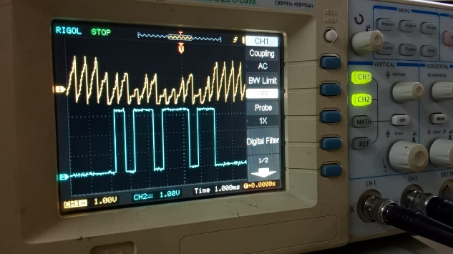

CH1: TP15 CH1: TP15

CH2: TP17 CH2:TP17

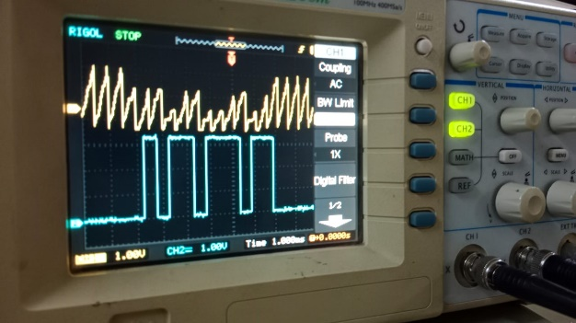 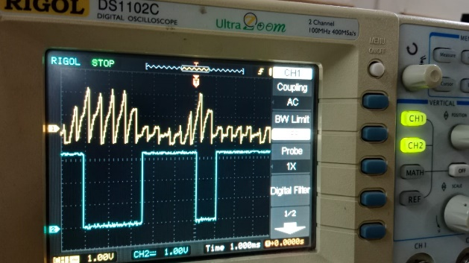

CH1: TP3 CH1: TP3

CH2: TP16 CH2:TP16

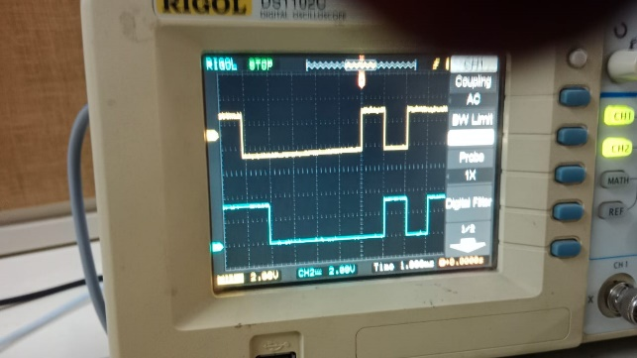 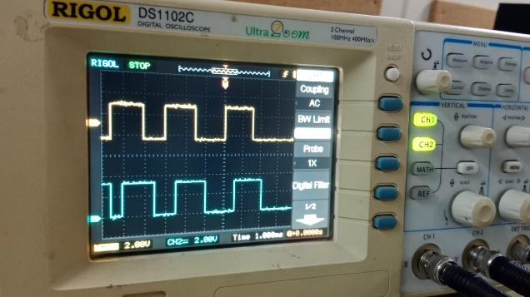

CH1: TP4 CH1: TP4

CH2: TP17 CH2:TP17

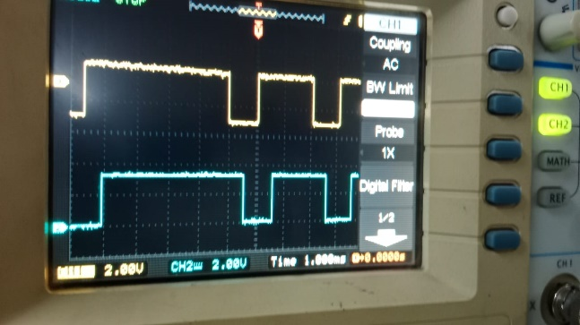 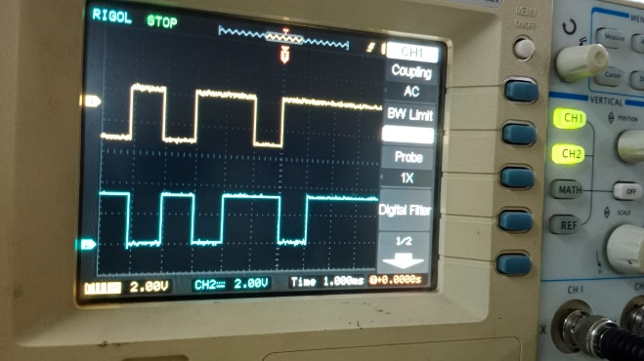

CH1: TP2 CH1: TP2

CH2: TP18 CH2:TP18

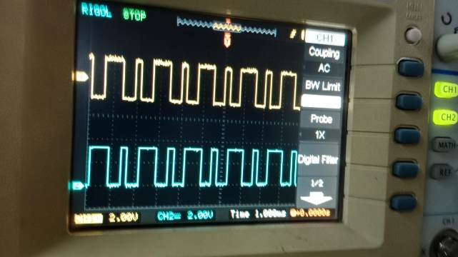 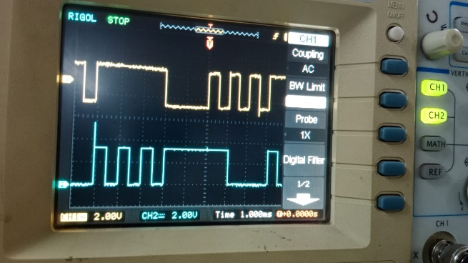

CH1: TP16 CH2: TP17 CH3:TP18

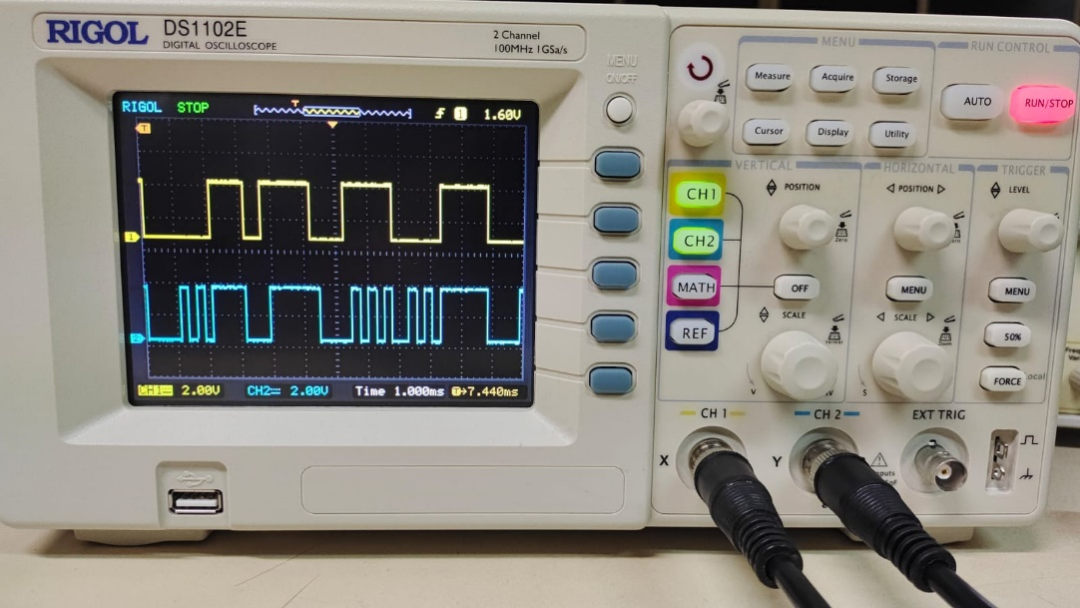 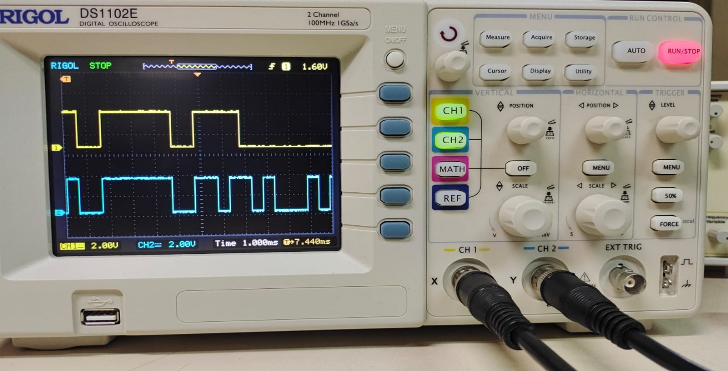

CH1: TP16 CH2: TP17 CH3:TP18

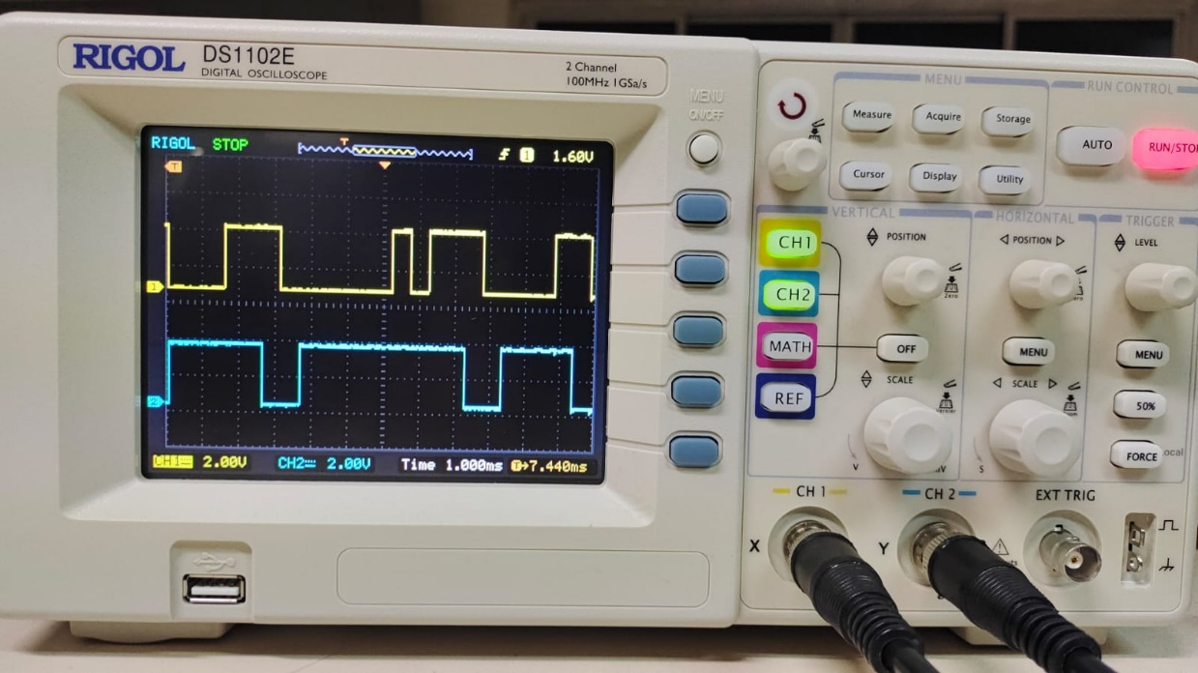 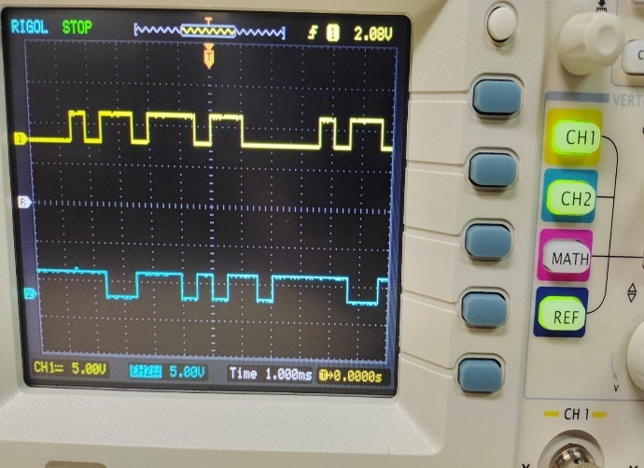

**Experiment 2:**

**Problem 5.1:**

A = 1; % Amplitude

Tb = 1; % Bit interval duration

numSamples = 10; % Number of samples per bit interval

sigma_squared_values = [0, 0.1, 0.5, 1.0]; % Values of noise variance

for sigma_squared = sigma_squared_values

% Generate the noise sequence

nk = sqrt(sigma_squared) * randn(1, numSamples * 2); % Generate Gaussian noise

s0_samples = [A * ones(1, numSamples), -A * ones(1, numSamples)];

received_s0 = A + nk;

s1_samples = [A * ones(1, numSamples), -A * ones(1, numSamples)];

received_s1 = [A + nk(1:numSamples), -A + nk(numSamples+1:end)];

correlation_s0 = zeros(1, numSamples);

for k = 1:numSamples

correlation_s0(k) = sum(received_s0 .* circshift(s0_samples, [0, k-1]));

end

correlation_s1 = zeros(1, numSamples);

for k = 1:numSamples

correlation_s1(k) = sum(received_s1 .* circshift(s1_samples, [0, k-1]));

end

figure;

subplot(2, 1, 1);

stem(1:numSamples, correlation_s0);

title(['Correlation with s0(t) for \sigma^2 = ' num2str(sigma_squared)]);

xlabel('Time instants (k)');

ylabel('Correlation output');

subplot(2, 1, 2);

stem(1:numSamples, correlation_s1);

title(['Correlation with s1(t) for \sigma^2 = ' num2str(sigma_squared)]);

xlabel('Time instants (k)');

ylabel('Correlation output');

end

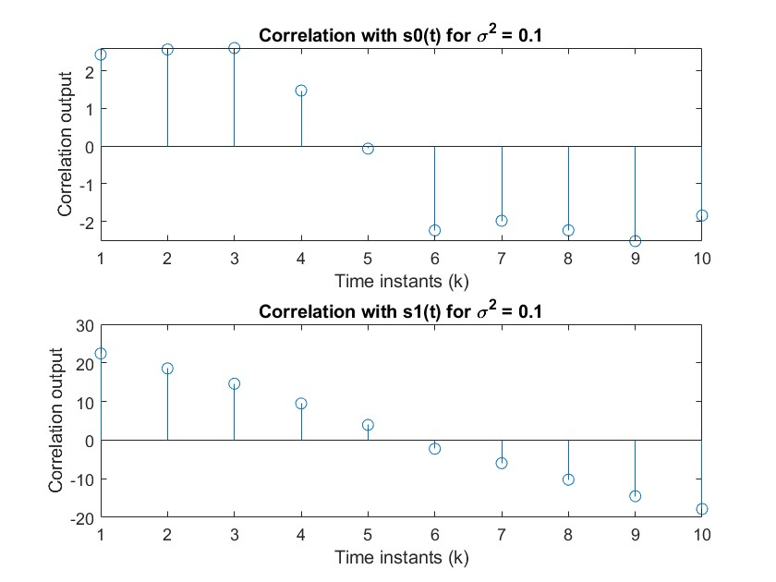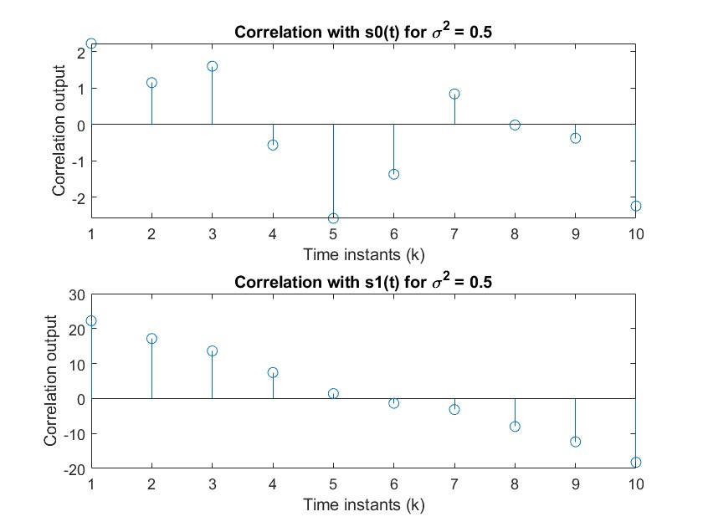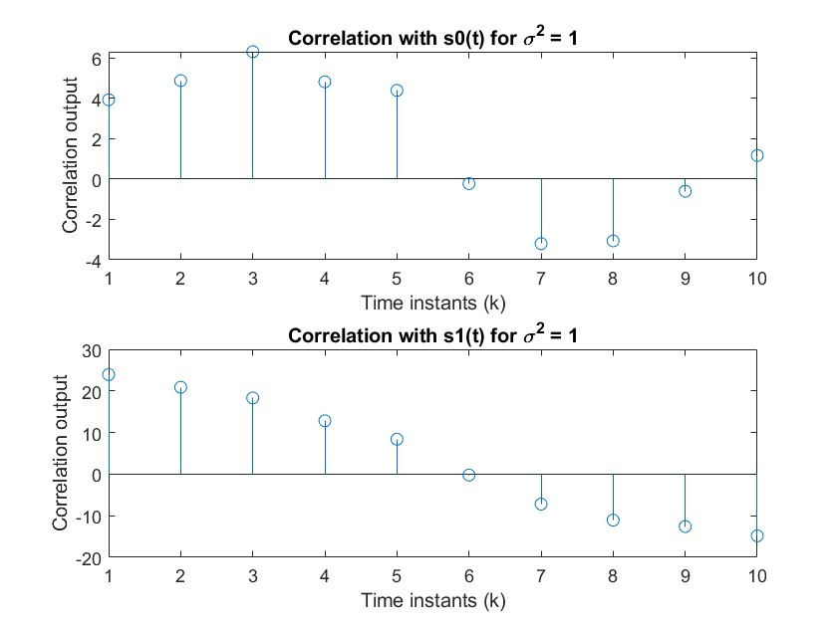

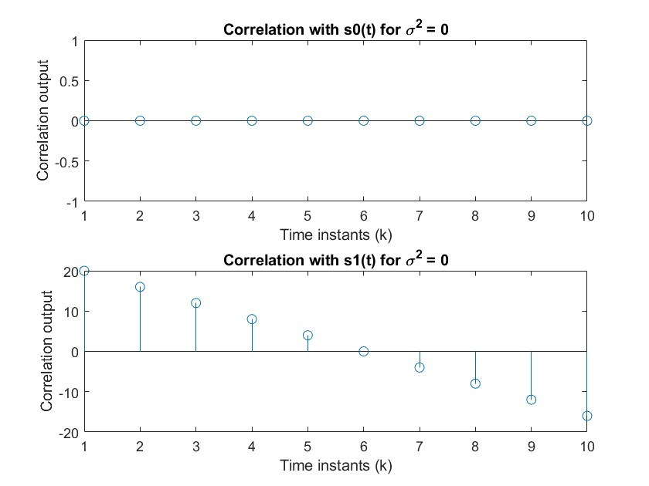

**Problem 5.11:**

num_symbols = 10000;

symbols = 2 * (randi([0, 1], 1, num_symbols) * 2 - 1);

noise_variance = 0; % Setting noise variance to 0

noise = sqrt(noise_variance) * randn(1, num_symbols);

received_symbols = symbols + noise;

decoded_symbols = zeros(size(received_symbols));

decoded_symbols(received_symbols < -2) = -3;

decoded_symbols(received_symbols >= -2 & received_symbols < 0) = -1;

decoded_symbols(received_symbols >= 0 & received_symbols < 2) = 1;

decoded_symbols(received_symbols >= 2) = 3;

symbol_errors = sum(decoded_symbols ~= symbols);

simulated_symbol_error_rate = symbol_errors / num_symbols;

theoretical_symbol_error_rate = 0;

fprintf('Simulated Symbol Error Rate: %.6f\n', simulated_symbol_error_rate);

fprintf('Theoretical Symbol Error Rate: %.6f\n', theoretical_symbol_error_rate);

samples_to_plot = 1000;

if samples_to_plot > num_symbols

samples_to_plot = num_symbols;

end

figure;

stem(1:samples_to_plot, received_symbols(1:samples_to_plot));

xlabel('Sample Index');

ylabel('Received Signal + Noise');

title('Received Signal-plus-Noise Samples at the Input to the Detector');

**Output:**

Sigma^2=0, 0.1, 0.5, 1

Simulated Symbol Error Rate: 1.000000

Theoretical Symbol Error Rate: 0.000000

Sigma=1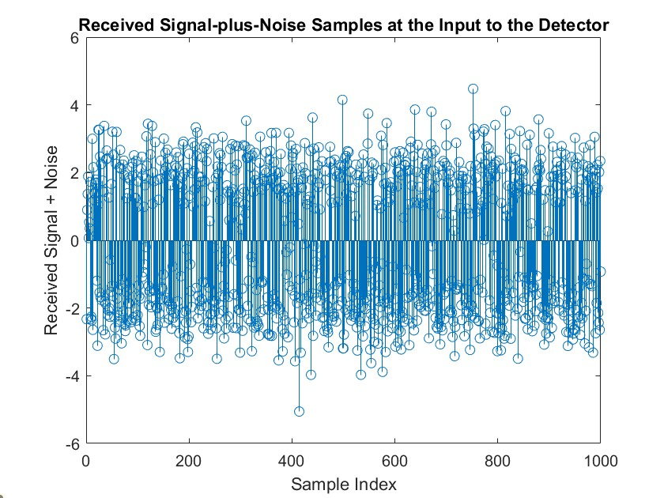Sigma=0.5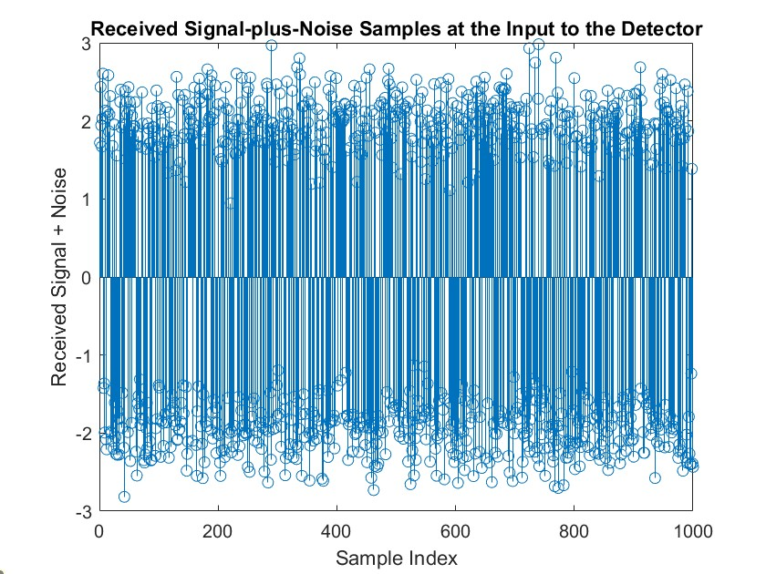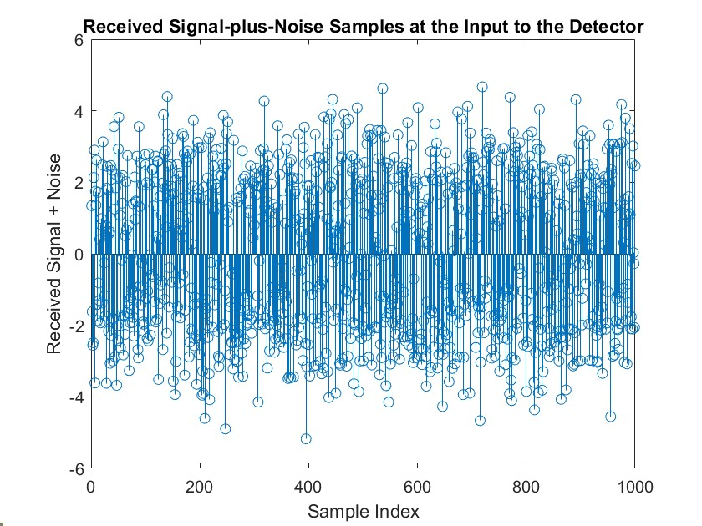Sigma=0.1

Sigma=0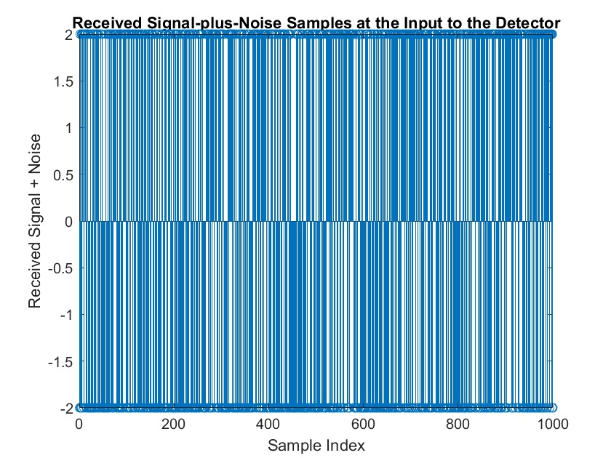

**Experiment: 3:**

**Problem 7.1:**

ex = 0.5; % Roll-off factor for square-root raised-cosine filter

T = 1; % Time period

fc = 40 / T; % Carrier frequency

f = linspace(-10/T, 10/T, 1000);

X_baseband = sinc(f * T) .* cos(pi * ex * f * T) ./ (1 - (2 * ex * f * T).^2);

carrier = zeros(size(f));

carrier(f == fc) = 1;

carrier(f == -fc) = 1;

Y_AM_PAM = conv(X_baseband, carrier, 'same');

figure;

subplot(2, 1, 1);

plot(f, abs(X_baseband), 'b');

title('Baseband Signal Spectrum (PAM with SRRC filter)');

xlabel('Frequency');

ylabel('Amplitude');

grid on;

subplot(2, 1, 2);

plot(f, abs(Y_AM_PAM), 'r');

title('AM-PAM Signal Spectrum');

xlabel('Frequency');

ylabel('Amplitude');

grid on;

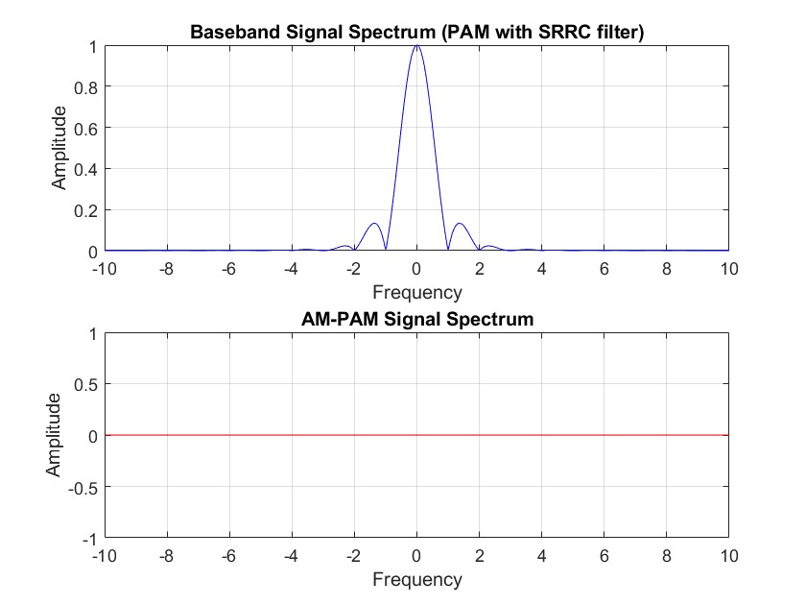

**Problem 7.7:**

T = 1; % Time period

fc = 6 / T; % Carrier frequency

M = 8; % Number of phases for PSK

t = linspace(0, T, 1000); % Time vector

GT = @(t) 0.5 * (1 - cos(2 * pi * t / T)) .* (0 <= t & t <= T);

theta = linspace(0, 2 * pi, M + 1); % Phase angles

theta = theta(1:M); % Remove the last angle to avoid overlap

PSK_waveforms = zeros(M, length(t));

for i = 1:M

PSK_waveforms(i, :) = cos(2 * pi * fc * t + theta(i)) .* GT(t);

end

figure;

for i = 1:M

subplot(M/2, 2, i);

plot(t, PSK_waveforms(i, :));

title(['Phase ' num2str(i)]);

xlabel('Time');

ylabel('Amplitude');

grid on;

end

sgtitle('8-PSK Signal Waveforms with GT(t) Pulse Shape');

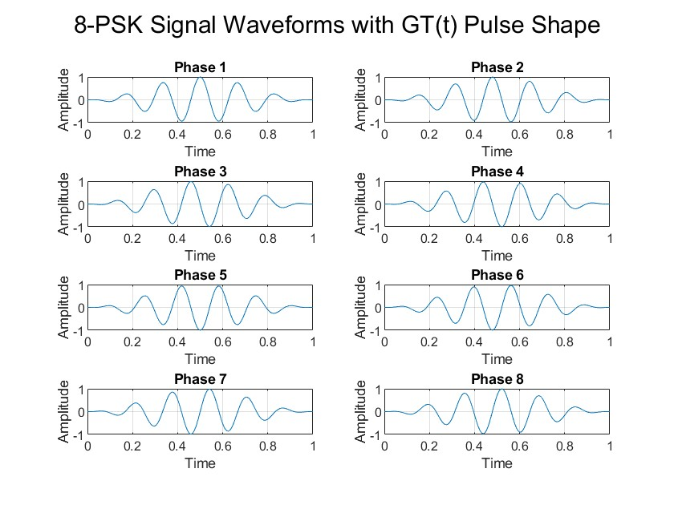

**Problem 7.9:**

M = 4; % Number of phases for PSK

Eb_N0_dB = 0:5:20; % Eb/N0 values in dB

num_symbols = 10^5; % Number of symbols to simulate

constellation = exp(1i * (0:2*pi/M:2*pi*(1-1/M))); % PSK constellation

for k = 1:length(Eb_N0_dB)

Eb_N0 = 10^(Eb_N0_dB(k) / 10); % Convert dB to linear scale

info_symbols = randi([1 M], 1, num_symbols);

transmitted_symbols = constellation(info_symbols); % Map symbols to constellation

noise_var = 1 / (2 * Eb_N0); % Calculate noise variance for given Eb/N0

noise = sqrt(noise_var) * (randn(1, num_symbols) + 1i * randn(1, num_symbols)); %

received_symbols = transmitted_symbols + noise; % Received symbols with noise

detected_symbols = zeros(1, num_symbols);

for i = 1:num_symbols

received_phase = angle(received_symbols(i));

[~, index] = min(abs(received_phase - angle(constellation)));

detected_symbols(i) = constellation(index);

end

symbol_errors = nnz(detected_symbols - transmitted_symbols);

symbol_error_rate(k) = symbol_errors / num_symbols;

end

figure;

semilogy(Eb_N0_dB, symbol_error_rate, 'o-', 'linewidth', 2);

title('Symbol Error Rate (SER) vs Eb/N0 for 4-PSK with Phase Detector');

xlabel('Eb/N0 (dB)');

ylabel('Symbol Error Rate (SER)');

grid on;

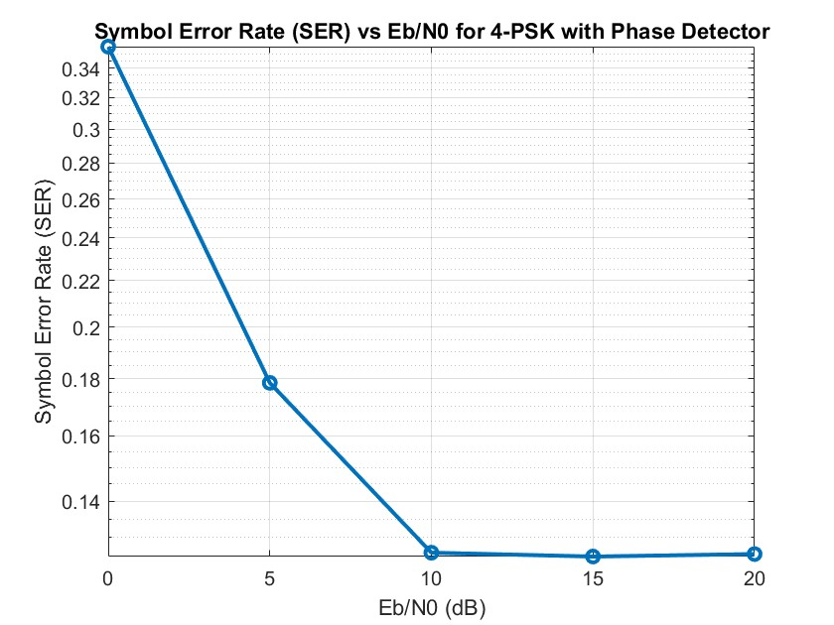

**Problem 7.12:**

T = 1; % Time period

fc = 8 / T; % Carrier frequency

A = sqrt(2) - 1; % Signal constellation amplitude factor

t = linspace(0, T, 1000); % Time vector

constellation = [

-A - 1i * A;

-A + 1i * A;

A - 1i * A;

A + 1i * A;

-A - 3i * A;

-A + 3i * A;

A - 3i * A;

A + 3i * A

];

figure;

for i = 1:size(constellation, 1)

% Generate waveform for each constellation point using rectangular pulse

waveform = real(constellation(i)) * cos(2 * pi * fc * t) + imag(constellation(i)) * sin(2 * pi * fc * t);

subplot(4, 2, i);

plot(t, waveform);

title(['8-QAM Waveform ' num2str(i)]);

xlabel('Time');

ylabel('Amplitude');

grid on;

end

sgtitle('8-QAM Signal Waveforms with Rectangular Pulse GT(t)');

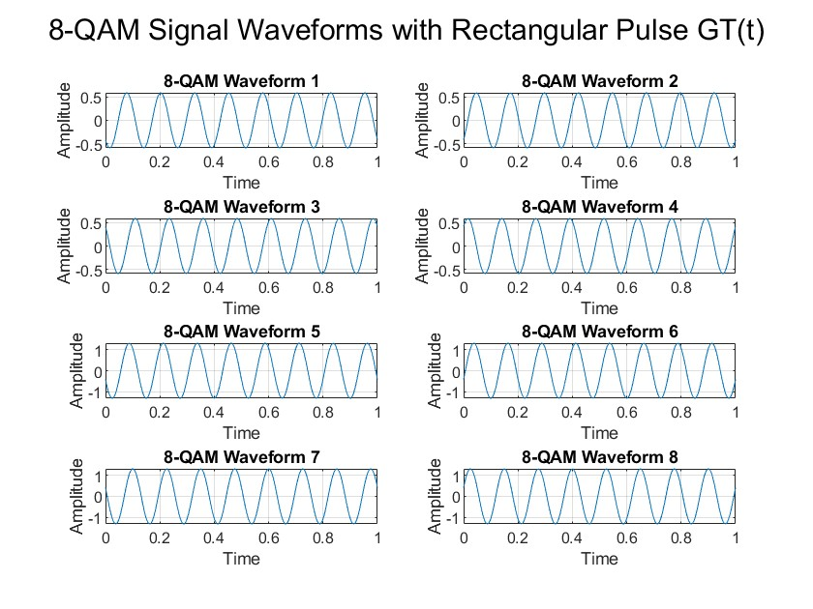

**Problem 7.17:**

M = 8; % Number of symbols in 8-QAM

num_symbols = 10000; % Number of symbols to simulate

Eb_N0_dB = 0:2:20; % Eb/N0 values in dB

Eb_N0 = 10.^(Eb_N0_dB / 10); % Convert Eb/N0 values to linear scale

constellation = [

-3-3i;

-3-1i;

-3+3i;

-3+1i;

-1-3i;

-1-1i;

-1+3i;

-1+1i

];

SER_simulated = zeros(1, length(Eb_N0));

SER_upper_bound = zeros(1, length(Eb_N0));

for k = 1:length(Eb_N0)

info_symbols = randi([1 M], 1, num_symbols);

transmitted_symbols = constellation(info_symbols); % Map symbols to constellation

normalized_symbols = transmitted_symbols / sqrt(mean(abs(transmitted_symbols).^2));

sigma = 1 / sqrt(2 * Eb_N0(k)); % Calculate noise standard deviation

noise = sigma * (randn(1, num_symbols) + 1i * randn(1, num_symbols)); % Complex Gaussian noise

received_symbols = normalized_symbols + noise;

detected_symbols = zeros(size(received_symbols));

for i = 1:num_symbols

[~, index] = min(abs(received_symbols(i) - constellation));

detected_symbols(i) = constellation(index);

end

symbol_errors = nnz(detected_symbols - transmitted_symbols);

SER_simulated(k) = symbol_errors / num_symbols;

SER_upper_bound(k) = 2 * qfunc(sqrt(3 * Eb_N0(k))); % Theoretical upper bound formula

end

figure;

semilogy(Eb_N0_dB, SER_simulated, 'o-', 'linewidth', 2, 'DisplayName', 'Simulated SER');

hold on;

semilogy(Eb_N0_dB, SER_upper_bound, 'r--', 'linewidth', 2, 'DisplayName', 'Theoretical Upper Bound');

title('Symbol Error Rate (SER) vs Eb/N0 for 8-QAM System');

xlabel('Eb/N0 (dB)');

ylabel('Symbol Error Rate (SER)');

legend('Location', 'best');

grid on;

